Problem Name: Nearest Left Node in a Binary Tree

Problem Statement:

Given a binary tree and a target node, your task is to find the nearest left node on the same level as the target node. If the target node is the leftmost node on its level, return -1.
You are given the root of a binary tree and a reference to a node u in the tree. Your task is to find and return the nearest node to the left of u on the same level. If no such node exists (i.e., u is the leftmost node on its level), return -1.

Brute Force Approach:
- Traverse the tree using level order traversal.
- At each level, store the nodes in an array or list.
- For the level where the target exists, find the node and return the node to its left, if any.
- Time complexity: O(n) space and time.

Time Complexity:
- O(n) — where n is the number of nodes in the tree (due to level-order traversal).

Space Complexity:
- O(n) — for storing nodes at each level and for the queue used in traversal.

Code

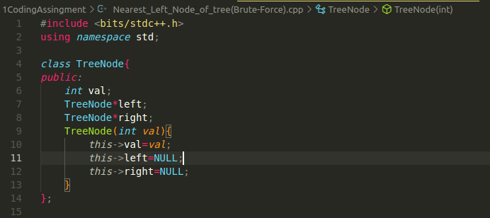

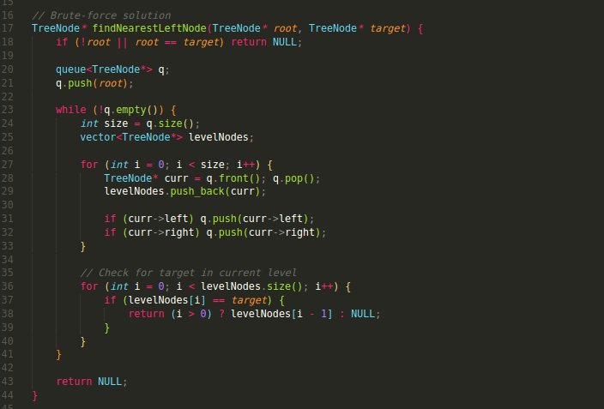
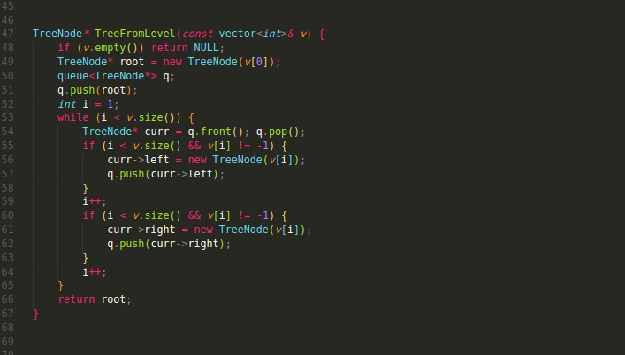

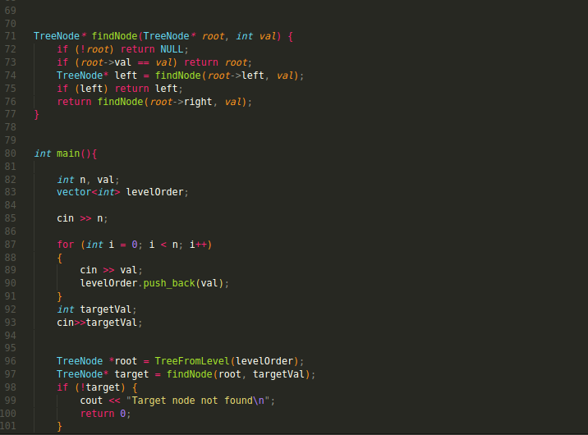
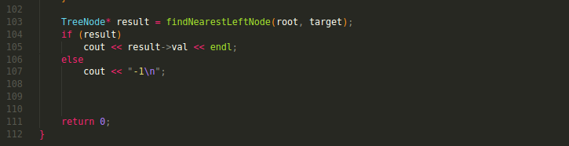

Approach (Optimized Brute Force using BFS)
- Perform a level-order traversal using a queue.
- For each level, track the prev node (i.e., the last node visited in the current level).
- If the current node is the target u, return prev.
- At each level, before moving to the next node, update prev = curr.
- If no left neighbor is found, return NULL.

Time Complexity
- O(n) — where n is the number of nodes in the tree (due to level-order traversal).

Space Complexity
- O(1) – As we are not Storing Any Element in array
Code

